Circuit Analysis Lab 3
Construction of Circuits:
Proteus Circuit:
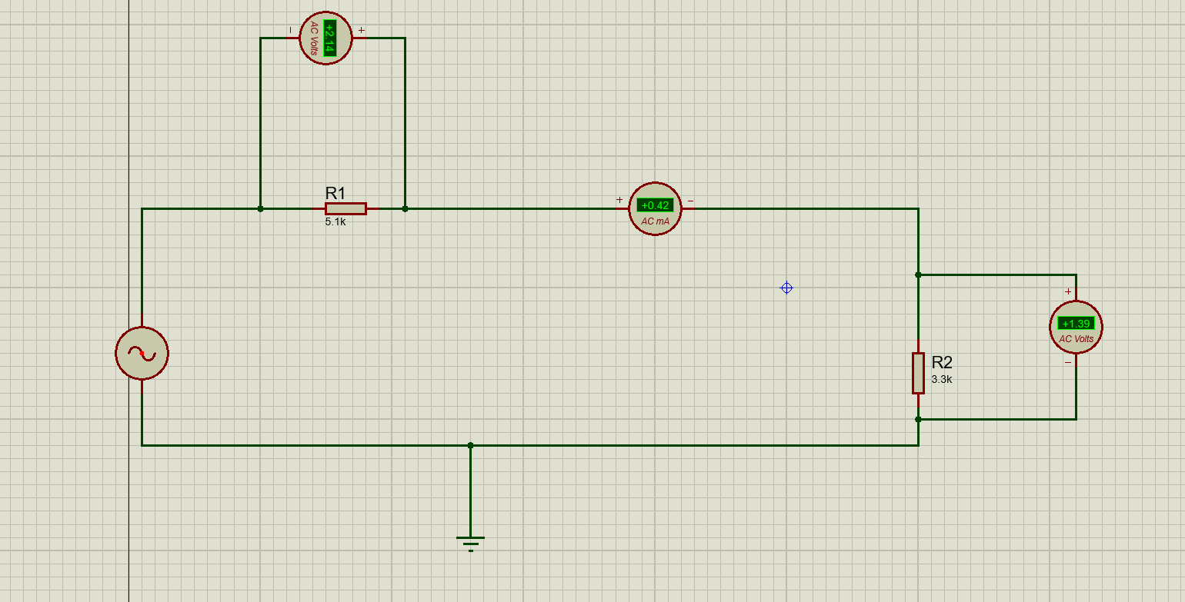

Explanation:
- Take an AC source (alternator) and connect its one terminal to resistor R1 (5.1 kΩ)
- From the other end of R1, connect a wire and place an ammeter in series
- From the ammeter, connect the wire to resistor R2 (3.3 kΩ)
- From the lower end of R2, connect the wire back to the other terminal of the AC source to complete the circuit
- Connect a voltmeter in parallel across R1 (one terminal before R1 and one after R1)
- Connect another voltmeter in parallel across R2 (one terminal at top of R2 and one at bottom of R2)
- Connect the bottom line of the circuit to ground as a reference point
- Ensure all connections are tight so current flows from source → R1 → ammeter → R2 → back to source
Proteus Circuit:

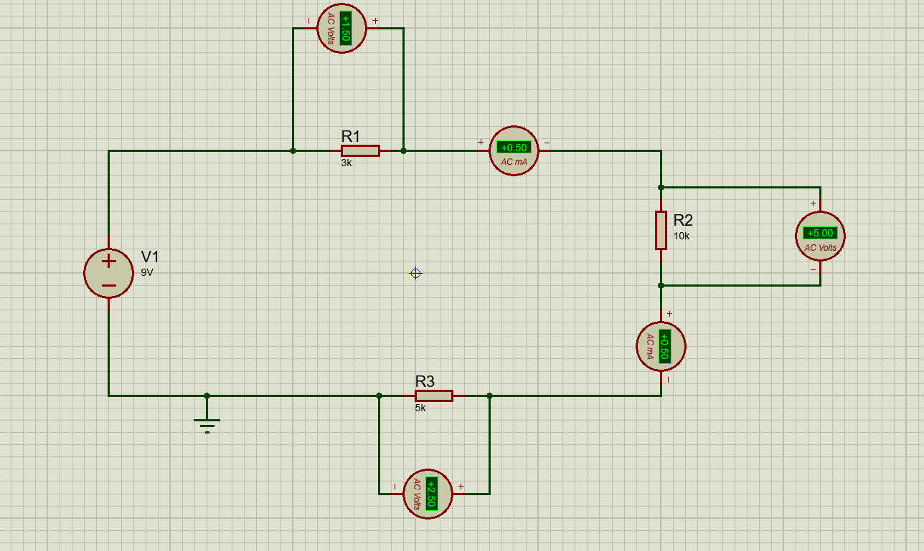

Explanation:
- Take a DC source (9V battery) and connect its positive terminal to resistor R1 (3 kΩ)
- From the other end of R1, connect a wire and place an ammeter in series
- From the ammeter, connect the wire to resistor R2 (10 kΩ) on the right side
- From the lower end of R2, place another ammeter in series in the vertical path
- From this ammeter, connect the wire to resistor R3 (5 kΩ) at the bottom
- From the other end of R3, connect the wire back to the negative terminal of the battery to complete the loop
- Connect a voltmeter in parallel across R1 (one terminal before R1 and one after R1)
- Connect another voltmeter in parallel across R2 (one terminal at top of R2 and one at bottom of R2)
- Connect a third voltmeter in parallel across R3 (one terminal before R3 and one after R3)
- Connect the bottom line to ground as a reference point
- Ensure all components are properly connected so current flows in a single loop through R1 → R2 → R3 → back to source

